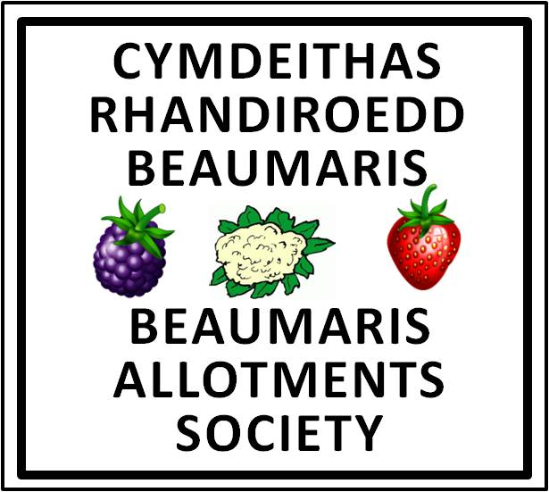

over100years …and still growing
Yma ers 100 mlynedd……… ac yn dal i dyfu
Annual General Meeting – 7th April 2024
AGENDA

7.00 pm David Hughes Centre, Beaumaris

1. Apologies for absence

2. Adoption of Minutes of last AGM - January 2023

3. Matters arising

4. Chairman's Report

5. Treasurer's Report
(a) Proposal to accept Accounts
(b) Proposal regarding Annual Subscription to the Society
(c) Proposal to continue membership of National Allotments Society

7. Election of Officers

8. Any other business

