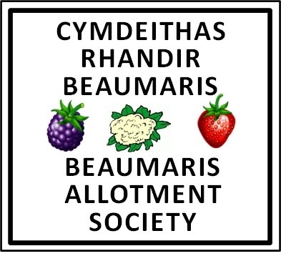
over100years …and still growing
Yma ers 100 mlynedd……… ac yn dal i dyfu

Notice of Annual General Meeting 2024

David Hughes Centre, Beaumaris – 7pm, Sunday, 7th April 2024
NOMINATION FORM FOR THE ELECTION OF OFFICERS
Should you wish to nominate any person for any of the posts listed below,
please enter the details in the relevant boxes and email the completed form to beaumarisallotmentsociety@outlook.com
Post | Current holder | Person Standing | Person Nominating | Person Seconding
CHAIR | Vacant
SECRETARY | Andrew Dixon
TREASURER | Chris Gibbs
HEALTH &  SAFETY OFFICER | Colin Heath
MEMBERSHIP SECRETARY | Nicky Thomas
SITE MANAGER | Sally Quest
EVENTS CO-ORDINATOR | Anne Bailey-Maddox
PUBLICITY OFFICER | Jill Anker

