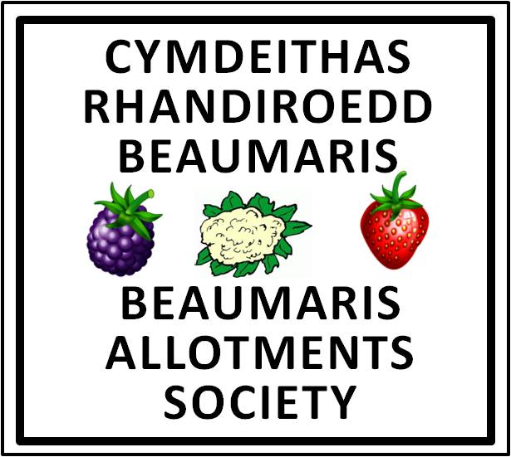
Beaumaris Allotment Society
Annual General Meeting 15th October 2021
Context.
This AGM was held on 15th October using a multi participant ZOOM call. In addition, and to ensure that members were not disenfranchised by this technological approach, members were also able to vote by email and in person at the open-air BAAFTAs held a few days earlier.
The vote recorded in these minutes are a combination of all three methods of voting.
23 members voted prior to 15th October and 12 members took part in the ZOOM conference. At the time of the AGM, the Society recorded 62 members and the quorum at that time was 21; one third of members. The total number of participants was 35.

1. Apologies for absence
Apologies had been received from Neil and Samantha Hayes, Kerry and Stan Zalot, Hilary Miller, Gwilym Evans, Gary and Mari Lloyd Pritchard, Joan and Bill Hopkin, Arfon and Belinda Thomas, Sarah Finnegan Dehn, Sophie Mohun Kemp, Henri Mariivioet, Mandy and Wyn Jones, Sara and Paul Jones and Rhiannon Thompson

2. Minutes of the last AGM in March 2019
Proposed by the chairman and seconded by Keevan Anker
In favour 34 votes. Against 1 vote. The minutes were accepted
The minutes were signed as a true copy by the Chairman.

3. Matters arising
Mo matters raised

4. Chairman’s report
Accepted as written.

5. Prevention of Bullying and Harassment policy
The background was outlined by the Chair. It had become usual practice in many Allotment Societies to have such a policy and our Society had had to deal with a couple of instances in recent years without the benefit of a policy to rely on. In the worst case scenario it would enable the Society to revoke the tenancy of a member found to have been bullying or harassing others.
Seconded by Chrissy Newsham.
In favour 34 votes. Against 1 vote. The policy was approved.

6. Revised Constitution of the Society
The existing constitution had served the Society for more than 20 years but during that time it became clear that the expectations of the Town Council and of the landlord, Sir Richard Bulkeley, were not adequately represented by the constitution. As a consequence, members and the Society were required to abide by a range of rules and regulations, only some of which were written down and those that were written down were in several different places. These included the tenancy agreement, the constitution and the Dos and Don’ts document. The revised Constitution proposed had brought all those differing sets of rules and regulations into a joint document that had been agreed with the Town Council.
Seconded by Peter Thomas
In favour 34 votes. Against 1 vote. The new constitution was approved.

7. Conversion to a small charity.
Proposal to permit the Committee to make progress in working towards establishment as a small charity. Prior to taking the final step, members would be consulted again.
Seconded by Keevan Anker
In favour 34 votes. Against 1 vote. The proposal was accepted

8. Continued membership of NSALG
NSALG now provides our third party liability insurance as well as a range of other benefits all from the single membership fee.
Seconded by Keevan Anker
In favour 34 votes. Against 1 vote. The proposal was accepted

9. Treasurer’s report.
The current report was on a different financial year than at previous AGMs. This was to enable it to be more relevant to the AGM. Income and expenditure were consistent with previous years discounting the major events such as the BAAFTAs. There was significantly increased revenue from King’s Seeds. There was a concern about controls on expenditure and the need to balance such controls against the need to be responsive to changing circumstances. Concerns were raised from the floor about the difficulties of managing events with unpredictable numbers of members attending. In discussion it was agreed that the Committee would need to clarify how such controls should work.
A query was raised about low subscription income in the period. This was due to the foreshortened reporting period which did not include a period in which subs were being paid. The treasurer clarified that subs now covered the period January 1st to December 31st of each year but that many members paid early. New members joining after 1st September in any year would also be covered for the whole of the following year.
The report was seconded by Ann Bailey-Maddox.
In favour 34 votes. Against 1 vote. The report was accepted

10. Subscription level for 2021/ 2022
The Treasurer proposed that the subscription rate be unchanged at £10 per plot per year.
Seconded by Chrissy Newsham.
In favour 34 votes. Against 1 vote. The proposal was accepted.

11. Health and Safety Officer’s Report.
A Risk assessment of the plots was a requirement both of the Town Council and of our insurers. Without such an assessment our insurers might be reluctant to pay out on a claim if a risk that could have been foreseen was not identified and mitigated.
In favour 34 votes. Against 1 vote. The risk assessment was accepted

12. Membership Report.
Noted that almost all Associate Members on the waiting list had been allocated a plot. Thanks were extended to Joan Hopkin for the excellent and reliable way that the role of Membership Secretary role had been undertaken.

13. Election of officers
In the absence of any new nominees to serve on the Committee in any of the key roles, and following the resignations of Chrissy Newsham and Joan Hopkin , the following were proposed.

Chair Andrew Dixon
Vice Chair Steve Blight
Membership Secretary Jill Anker
Site Manager Will Roberts
Health and Safety advisor Andrew Dixon
Events organisers Mari Lloyd Pritchard and Ann Bailey Maddox
Publicity Jill Anker

Seconded by Liz Alun-Jones
In favour 34 votes. Against 1 vote. The committee was elected

- AOB
Chrissy Newsham extended a vote of thanks to the Chair/ Secretary for his work during the past year. Endorsed by all present.

The virtual meeting closed at 19.56 – 15th October 2021

